Dyess Air Force Base
First Term Officer Course
Student Handbook







Authored and Assembled by:
2d Lt Brianna Johndrow
Capt Whitney Howard
1st Lt Hunter Phan
1st Lt Erin Glancey
Table of Contents

CHAPTER 1: COURSE INTRODUCTION………………………………………………….....
CHAPTER 2: COMMANDER’S INTENT……………………………………………………..
CHAPTER 3: KEY AFIs AND REGULATIONS………………………………………………
CHAPTER 4: FORCE SUPPORT SQUADRON SERVICES/ MANPOWER…………….....
CHAPTER 5: CGO TIPS & TRICKS…………………………………………………………...
CHAPTER 6: EDUCATION & TRAINING……………………………………………………
CHAPTER 7: TEAM BUILDING…………………………………………………………….....
CHAPTER 8: TEAM DYESS…………………………………………………………………….
CHAPTER 9: AF PORTAL UTILIZATION…………………………………………………...
CHAPTER 10: OFFICER PYRAMID/PATHWAY……………………………………………
CHAPTER 11: PROMOTIONS/TALENT MARKET PLACE………………………………..
CHAPTER 12: ENLISTED PERFORMANCE RECORD (EPR)/OFFICER PERFORMACE RECORD (OPR)/AIRMAN LEADERSHIP QUALITIES (ALQS) ……………………………………………………………................................................................
CHAPTER 13: AF1206 WORKSHOP……………………………………………………...…...
CHAPTER 14: FINANCES………………………………………………………………………
CHAPTER 15: COMMANDER’S TOOLBOX & PROGRESSIVE DISCIPLINE…………..
CHAPTER 16: EMOTIONAL INTELLIGENCE……………………………………………...
CHAPTER 17: LEADERSHIP 101………………………………………………........................
CHAPTER 18: SENIOR LEADERSHIP PERSPECTIVE………………………………….....
CHAPTER 19: INSPECTOR GENERAL………………………………………………………
CHAPTER 20: SEXUAL ASSAULT PREVENTION RESPONSE…………………………...
CHAPTER 21: FIRST SERGEANT PANEL…………………………………………………...
CHAPTER 22: ENLISTED FORCE STRUCTURE……………………………………………

Chapter 1: Course Introduction
Welcome to the world’s greatest Air and Space Force! You have been charged with the duty to lead some of the sharpest minds and a force dedicated to excellence.
Welcome to First Term Officer Course (FTOC)! FTOC is designed to provide brand new Second Lieutenants, First Lieutenants, and Captains the foundation to successfully integrate into their first assignment, as well as to build fundamental skills for new officers. This three-day professional development course will consist of exercises, leadership panels, workshops, and lesson plans which are designed to engage each student. FTOC’s goal is to not only instill a sense of confidence in young officers but to charge them with feeling empowered to be the best officers in the Air Force and Space Force! There are so many resources the Department of the Air Force (DAF) has for how to operate as a member of the DAF. Your student handbook will serve as supplemental information to each lesson as well as a one shot document to tie in DAF provided resources.

FTOC Objectives:
- Professional development foundation
- Networking
- Understanding resources-Department of the Air Force (DAF) and Team Dyess
- Confident new officers
- Understanding different leadership perspectives

Chapter 2: Commander’s Intent

“Leadership is a gift. It’s given by those who follow, but you have to be worthy of it. The men and women that you’re going to be responsible for are the greatest people in the planet. You better be getting ready to lead them.”
- General Mark A. Welsh III, Chief of Staff, USAF (Retired)
As an officer you are not only expected to be knowledgeable on the mission but on how to best lead and serve your people. You should know what fuels your organization, what your commander’s priorities are, and what your Airmen and Guardians truly need to operate. You should also be knowledgeable on the Installation Commander’s Line of Efforts (LOE) in order to tie the strategic focus to the tactical level in which you will operate at your first couple of years. The art of leadership is not a skill that is acquired over the course of an officer's first assignment, but is a continuous process of personal and professional development that will endure well after you have parted from the DAF. Therefore, it is imperative that you employ the resources within this guide to begin to sharpen your leadership skills at the onset of your career. Learn from your mistakes, move on, and always keep working to improve. Learn from other leaders through both positive and negative examples to grow as an officer. Reading can help develop the mind, promote innovation, and pride insight on different leadership theories and insights. Here is a recommended reading list for your toolbox:
- National Defense Strategy:
https://www.defense.gov/Spotlights/National-Defense-Strategy/
- General C.Q. Brown’s USAF Strategy: https://www.af.mil/Portals/1/documents/2020SAF/ACOL_booklet_FINAL_13_Nov_1006_WEB.pdf
- General Raymond’s USSF Priorities: https://www.spaceforce.mil/News/Article/2409479/raymond-document-outlines-space-forces-management-practices-priorities-and-iden/
- Heirpower! Eight Basic Habits of Exceptionally Powerful Lieutenants:
https://www.airuniversity.af.edu/AUPress/Display/Article/1533264/heirpower-eight-basic-habits-of-exceptionally-powerful-lieutenants-online-only/
- The Armed Forces Officer:
https://ndupress.ndu.edu/Portals/68/Documents/Books/AFO/Armed-Forces-Officer.pdf
- CSAF Reading List (Includes CMSAF):
https://fairchild-mil.libguides.com/c.php?g=906591&p=8275586
- News you should subscribe to:
  - https://www.airforcetimes.com/
  - https://www.airforcemag.com/
  - https://www.defensenews.com/
Chapter 3: Key DAF Regulations
To successfully lead it in the DAF it is vital to be knowledgeable on key regulations which govern how Airmen and Guardians operate when performing their jobs. Here are some regulations to have in an officer’s toolbox:
Note: You should always pull regulations and forms through DAF E-Publishing tool found on the Air Force portal- https://www.e-publishing.af.mil/
- AFI 1-1: AIR FORCE STANDARDS
- AFI 1-2: COMMANDER’S RESPONSIBILITIES
- AFI 36-2406: OFFICER AND ENLISTED EVALUATIONS SYSTEMS
- AFI 36-2907: ADVERSE ADMINISTRATIVE ACTIONS
- DAFI 36-3003: MILITARY LEAVE PROGRAM
- DAFM 36-2905: DEPARTMENT OF THE AIR FORCE PHYSICAL FITNESS PROGRAM
- DAFI 36-2903: DRESS AND PERSONAL APPEARANCE OF UNITED STATES AIR FORCE AND UNITED STATES SPACE FORCE PERSONNEL
- AFI 36-7001: DIVERSITY & INCLUSION
- AFH 33-337: THE TONGUE AND QUILL
- DAFI 36-2110: TOTAL FORCE ASSIGNMENTS
- DAFI 36-2670: TOTAL FORCE DEVELOPMENT
- DAFI 36-2501: OFFICER PROMOTIONS AND SELECTIVE CONTINUATION
- AFH 36-2643: AIR FORCE MENTORING PROGRAM
- AFI 36-3012: MILITARY ENTITLEMENTS
- DAFI 36-2906: PERSONAL FINANCIAL RESPONSIBILITY
- AFI 36-2909: AIR FORCE PROFESSIONAL RELATIONSHIPS AND CONDUCT
- DoD 5500.07-R: JOINT ETHICS REGULATION

The DAF E-Publishing website also links to other DoD and other external sources which include key regulations: https://www.e-publishing.af.mil/otherpublishingsites/ . Users can use this function to link to websites to find non DAF regulations and forms such as Joint Federal Travel Regulations (JFTR), Optional Forms (OF), Joint Publications (JP), Department of Defense Instructions (DoDI), etc.

Email (Outlook). This is your primary means of communication and appointment scheduling.

Tips
- If you are asked to find an individual in Global or GAL, you will refer to your Outlook Address Book to find the specified individual.
- Recall Email: Open the email you want to recall, then Select Message > Actions > Recall This Message.
- Out-of-Office Message: Anytime you are going to be away from the office for long periods of time, it is expected that you will set up an automatic out-of-office message. Leave specifics to a minimum (OPSEC). Add a point of contact for the individual who will take over your program(s) temporarily while you are away.
- Add a signature block to every email correspondence. You should reference AFH 33-337, The Tongue and Quill Chapter 12 to reference what is and is not authorized in an email signature block.

FIRST M. LAST, Rank, USAF
Duty Title
Location
Official Email
Office Number
Updating GAL. The GAL your online profile which ties to your email and other information systems.
- Go to the vESD App (Help Desk icon)
- Select 'Go to MyGAL' at the top, this will take you directly to the website update your contact information
- Scroll down until you see 'Office Symbol' and select the link 'User Self Help'
- Select your correct Certificate
- A new link will direct you to Air Force Directory Services where you can update your Office Symbol and DSN
- When all changes have been made, select 'Save'
- All changes can take up to 24 hours to update in the GAL
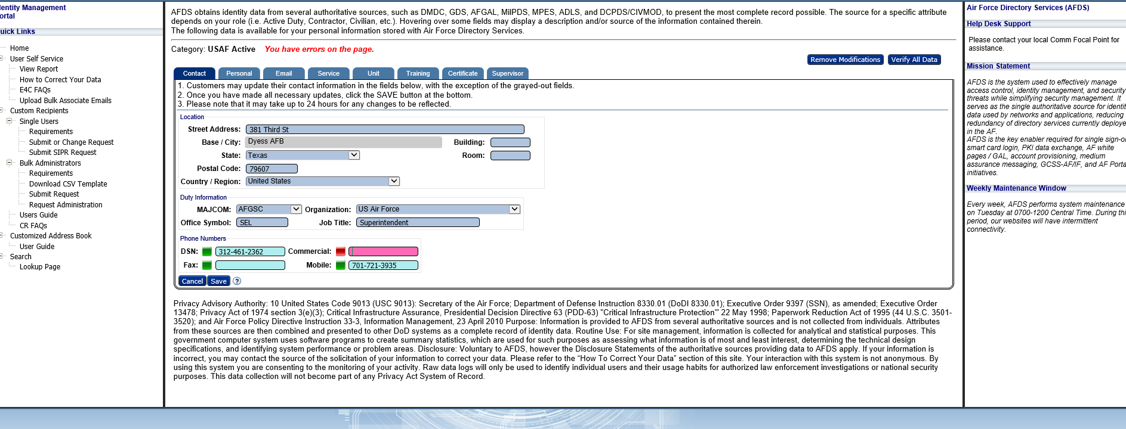

Electronic Staff Summary Sheet (eSSS): An eSSS is s a versatile tool that introduces, summarizes, and coordinates staff packages electronically while utilizing the chain of command and staff officers to get your information to the correct decision-makers. The decision-maker will then have the final draft of the package so they may approve, sign and implement actions outlined in the requested package. Your Commander Support Staff (CSS) should provide you a copy of an eSSS template:

AtHoc: The AtHoc system is utilized to notify members of urgent matters. You must ensure your AtHoc profile is updated upon PCS-ing and whenever your information changes. Information includes contact information, home address, duty location, etc:

Chapter 4: Force Support Squadron Services/Manpower
The Force Support Squadron (FSS) oversees the Wing’s programs involving people, support, and overall quality of life of the installation. As an officer it is critical to become familiar with the different programs run by the FSS and the respective units with the FSS.
The Military Personnel Flight (MPF):
Address: 217 5th Street, Dyess AFB, TX 79607
Hours: Mon – Fri
8AM-11AM: Walk-In’s
12-3PM: Appointments Only
Closed every 3rd Thursday of the Month*
Appointment Scheduler: https://booknow.appointment-plus.com/b38qk7qm/
Force Management
- Classification, Evaluations, Adverse Actions, Duty Status, PCA
Relocations & Separations (Outbound Assignments)
- Assignments, Separations, Retirements, EFMP
Customer Support
- Line of duty determination, In-processing, CSS Training, Sponsorship, Officer Accessions, Awards & Decorations
Customer Service
- DEERS Contractors, ID Cards, G-Series
Installation Personnel Readiness (IPR)
- Deployment Orders, AFPAAS Briefings, Dog Tags
Retention & Promotions
- Promotions, Enlistment bonus, Re-enlistments, Extensions

Dyess Fitness Center:
Contact: (325) 696-4306
Address: 525 Ave B, Dyess AFB, TX 79607
Offerings:
Basketball & Volleyball Courts | Fitness Assessment Cell (FAC)
Indoor Running Track | Parent/Child Area (PAC)
Outdoor Running Track | Indoor Swimming Pool (Open Mon/Tues/Thurs/Fri)
Racquetball Court | Football Field
Group Exercise Rooms | 2 Softball Fields
Cardio & Free Weight Training | Alpha Warrior Rig

Dress Code: https://safe.menlosecurity.com/doc/docview/viewer/docNF254B7F231E5c3d3ead1763089281c1c387723170c23b5eda2c9cd76401ac930f24397bdf3f1

Dyess Dining Options:
Deadwood Café
- Located within Dyess Lanes
398 Ave C, Dyess AFB, TX 79607
- Monday-Thursday: 11 am - 8:30 pm
Friday: 11 am - 9:30 pm
Saturday: 2 - 9:30 pm​
- Closed on Sundays & holidays
- 325.696.4166

Flight Line Kitchen
- 3 Bay Hangar, Bld 5110, Dyess AFB, TX 79607
- Open 24/7
- Hot Meal Hours:
Breakfast 6:30 am - 9:00 am
Lunch 10:30 am - 1:30 pm
Dinner 4:30 pm - 8:30 pm​
- 325.696.8881

Longhorn Dining Facility
- 357 Ave B, Dyess AFB, TX 79607
- Monday-Friday:
  - Breakfast 6:00 am - 9:00 am
  - Lunch 10:30 am - 1:30 pm
  - Dinner 4:30 pm - 6:30 pm
- Weekends & Holidays:
  - Breakfast 7:30 am – 9:00 am
  - Lunch 10:30 am – 1:30 pm
  - Dinner 4:30 pm - 6:00 pm
- 325.696.2421

Out of Bounds Grill (Golf Course Cafe)
- 766 Mesquite Trail, Dyess AFB, TX 79607
- Monday-Friday:
- 8:00 am - 2:00 pm
- 325.696.4384

Child & Youth:

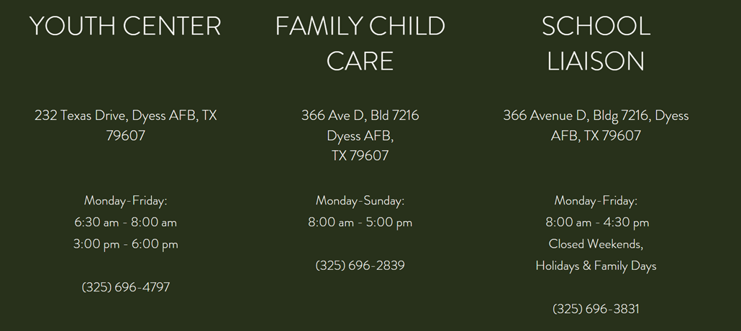
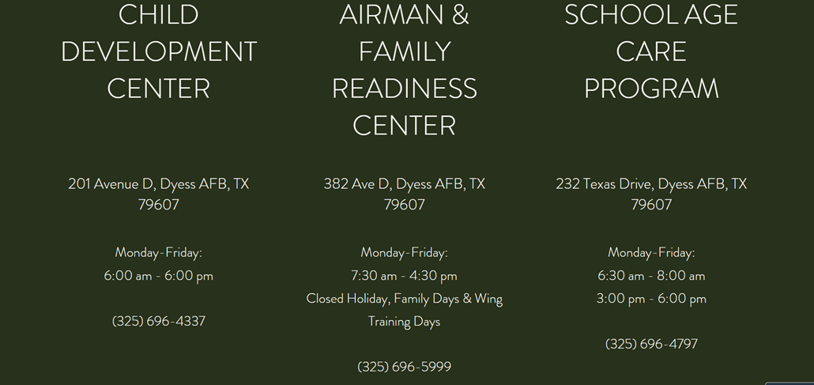

Outdoor Recreation:
- Phone: (325) 696-2402
- Address: 926 Louisiana Rd, Dyess AFB, TX 79607
- Hunting, skydiving, tubing, swimming, fishing, climbing - ODR has it all.
- https://www.dyessfss.com/outdoor-recreation
- Operating Hours: Monday, Tuesday, Thursday, Friday, Saturday:
  - 9:00 am - 5:00 pm
Closed on holidays
- FAM CAMP
- Swimming Pool
- Storage Rentals
- R4R (Recharge for Resiliency) Discounts
  - Single Airman Programs (SAPI): Open to unmarried (single) Air Force Active Duty members, reservists, and one guest
  - RecOn Programs: Air Force Active Duty, reservists, and their immediate family members
  - Deployed Affected Programs (DAP): Open to Air Force Active Duty & their immediate family - for a spouse & one guest while deployed

Mesquite Grove Golf Course:
- Phone: (325) 696-4384
- Address: 766 Mesquite Trail, Dyess AFB, TX 79607
Offerings:
18 Hole Course | Grill & Snack Bar
Rental Clubs | Driving Range
Golf Carts | Putting Green
Golf Repair Shop | Adult & Junior Lessons

Rates & Fees: https://safe.menlosecurity.com/doc/docview/viewer/docNE81F27C2D23713cb60c19a6079e8b8bfd5cc37ed2056d074e4092783d04f9ea1beeb5b0a000d

Dyess Inns:
- Phone: (325) 696-2681
- Address: 441 5th Street (Building 7409), Dyess AFB, TX 79607
- Open Daily:
  - 6AM – 10PM

UNITE Program:
- Phone: (325) 696-7969
- Address: 357 Ave B (Building 7106), Dyess AFB, TX 79607

Sponsorship & Advertising:
- Phone: (325) 696-4132
- Address: 210 Theater Road, Dyess AFB, TX 79607
- Monday-Friday:
  - 8AM – 5PM

Honor Guard & Mortuary Affairs:
- Address: 390 Ave D (Bldg 7217), Dyess AFB, TX 79607
- Honor Guard
  - (325) 696-5532
- Mortuary Affairs
  - (325) 260-4406
Education & Training:
- Phone: (325) 696-5544
- Address: 217 5th Street, Dyess AFB, TX 79607
- Monday, Wednesday, and Friday:
  - 8:00 am - 12:00 pm
- Tuesday and Thursday:
  - 12:00 pm - 4:00 pm
Closed holidays

AFPC Secure Sites:
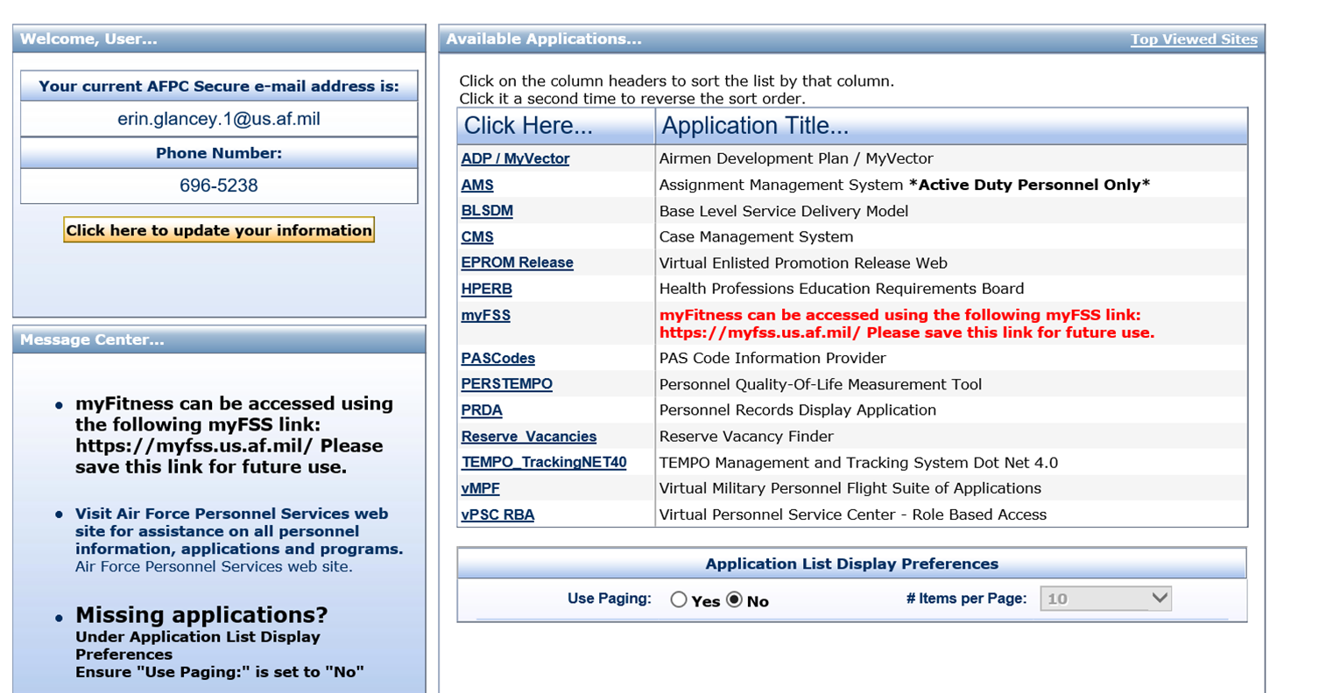

- MyVector: a platform to help expand & plan for your future career.
- AMS: Assignment Management System, you’ll go here to view your Career Data Brief (CDB) & SURF (Single Unit Retrieval Format).
- BLSDM: Base Level Service Delivery Model, you can view your unit’s Alpha roster, Gains/Loss Listing, Monthly Promotion Rosters, Evaluations Listing, Extended Tour Decoration Eligibility Roster, Late Evaluations, etc.
- CMS: Case Management System, this system is used to submit inquiries and trouble tickets up to AFPC whenever there are issues with your paperwork.
- EPROM Release: Virtual Enlisted Promotion Release Web, use this platform to view the most recent list of enlisted promotee’s.
- myFSS: Use this link to access the MyFSS Homepage where you can find links to myEval, myDecs, myFitness, myTraining, etc.
- PASCodes: Use this link to find the PAS Code for any unit/base. You’ll need to know your pass code for your OPR, 2096’s, & any administrative paperwork.
- PRDA: Personnel Records Display Application, this link will show all of your military records, OPR’s, decorations, etc.
- vMPF: Virtual Military Personnel Flight, you’ll use this site to update your vRED as well as out-process & view all past and present PCS orders.

Manpower Terminology:
- UMD – Unit Manpower Document
  - The amount of “spaces”/positions your unit is allocated/authorized.
- UPMR – Unit Personnel Management Roster
  - “Putting Faces to Spaces”
- Manpower Authorization – A funded manpower requirement with detail that defines the position in its function, organization, location, skill, grade, and other appropriate characteristics which commands use to extend end strength resources to units.
  - May appear as a “funded” or “unfunded” authorization on the Unit Manpower Document and in the Manpower Programming and Execution System.
- Manpower Requirement – Joint Publication 1 defines manpower requirements as human resources needed to accomplish a specific job, workload, mission, or program. There are two types of manpower requirements: funded and unfunded.
  - Funded manpower requirements are those that have been validated and allocated.
  - Unfunded requirements are validated manpower needs that have been deferred because of budgetary constraints. Manpower requirements are generally determined by an Air Force Manpower Standard or other management decision.
- Unfunded Manpower Requirement – An approved manpower requirement on the Unit Manpower Document that reflects recognized and/or necessary workload, however which is not funded—meaning no individual can be assigned to, or receive a permanent change of station order to the position.

Chapter 5: CGO Tips & Tricks
The following tips and tricks are to supplement advice given in the “What I wish I knew as a brand new O” panel. This list is not all inclusive and you should never stop seeking advice:
- Volunteer: While your number one priority is to learn your people and your job you should always want to volunteer to help inside and outside your organization.
- Network, network, network!: Try to meet people in every unit. This will go a long way when it comes to executing your mission.
- Join the Company Grade Officer Council (CGOC): The CGOC is a private organization in which all CGOs of all branches and components are welcome to join. The CGOC hosts events to include professional development, morale, fundraising, community service, and wing support. CGOC is also a great way to network.
  - Follow the CGOC on Facebook: Dyess CGOC
  - Dyess CGOC distro (request to be added by one of the CGOC executive council members): Dyess.CGOs@us.af.mil
  - Join the CGO Groupme:


- Service before self, but not in spite of self: The DAF is going to throw a lot at you when it comes to your job, leadership opportunities, additional duties, education, training, etc. Make sure you are not sacrificing your mental and physical health. Some additional resources which can help not only you as an officer physically and mentally but also help you assist your Airmen and Guardians include:
  - Physical Therapy
  - Mental Health/ Behavioral Health
  - Alcohol and Drug Prevention and Treatment Program (ADAPT)
  - Marriage and Family Counseling
- Be prepared for additional duties: Understand that you may be assigned to be a primary or alternate to an additional duty program. Additional duties are a great way to grow outside of the technical aspect of your job. You should be knowledgeable on how the Management Internal Control Toolset (MICT) works and the applicable regulations which govern your assigned additional duty program. Some additional duties you can be tasked with are:
  - Unit Training Manager (UTM)
  - Unit Deployment Manager (UDM)
  - Emergency Management Representative (EM) / Unit Control Center Manager (UCC)/ Emergency Operation Center (EOC)
  - Unit Fitness Program Manager (UFPM)
  - Facility Manager
  - Financial Resources/ Government Purchase Card (GPC) holder/ Resource Advisor (RA)/ Approving Official (AO)
  - Security Manager
- Understand your career progression: You should understand your Career Field Education Training Plan (CFETP), know who your Officer Assignment Team (OAT) is, and always ask questions. Take hold of your career!
- Seek out a Mentor: You should find a senior CGO, an SNCO, and a mentor from your career field at minimum.
- Practice bullet writing: The only one that should be writing your AF 1206 and OPR bullets is YOU. When there are opportunities to sit on a murder board (a review of awards packages) or take a bullet writing class do it! You will get the opportunity to review and dissect winning packages.
- Be humble: Yes you earned your rank, but understand there are so many people who would kill to be in your shoes. Do not let your rank go to your head. It is one thing for your Airmen and Guardians to have to respect your rank, but this does not mean they respect you as a leader. As an officer you serve your Airmen and Guardians. It is vital that you respect your enlisted troops opinions and perspectives. Enlisted members are a key source to your development as an officer. Earn their trust and followership. Understand that you need to be dedicated to learning your job, position as an officer, and how to be a member of the DAF.
- Pursue your Masters now: As you rise up the ranks and spend more time in the DAF, your schedule will become busier. You should also pursue a graduate degree that either adds value to your career or personal goals. Do not just check the box. Now is the time to pursue your masters. As you progress through your career, as the responsibilities both at work and at home tend to increase with promotions in rank and passing of time.
- Always seek feedback: You should seek feedback from your supervisor, senior leaders, SNCOs, peers, Airmen and Guardians you lead, and anyone who is willing to give you feedback. Do not settle for all positive feedback. You should demand constructive feedback in order to group.
- Keep a “love me binder”: Do not depend on Air Force systems such as PRDA, vMPF, etc. to hold your records. Keep hard copies of your orders, SURF/RIP, promotions, decorations, medical records, training records, etc. in either a hard copy binder or electronically. A good electronic resource is OneDrive: https://usaf-my.dps.mil/

Chapter 6: Education
The DAF is constantly encouraging Airmen and Guardians to pursue education and training. There are various programs and benefits that officers can take advantage of to pursue higher education. The Air Force Virtual Education Center (AFVEC) and myPers on the Air Force portal will provide information
Here are some tools for your toolbox:

Benefits-
Tuition Assistance: Tuition Assistance (TA) is outlined in DAFI 36-2670, Total Force Development, Chapter 6. In order to get started using Tuition Assistance, Air and Space Professionals should visit their local Education and Training Offices to get started and complete initial counseling. Using tuition assistance is linked to having an educational goal, a degree plan, and completing the required annual training associated with using Tuition Assistance and Credentialing Opportunities On-line (COOL) programs before requesting tuition assistance on-line through the Air Force Virtual Education Center (AFVEC). The fiscal year limit associated with tuition funds per member is $4,500 and $250 per semester hour or $166.66 per quarter hour. In addition, every class completed must have a reported grade. Members are required to reimburse the government for missing grades, non-completions, withdrawals, or unsatisfactory grades. To obtain the information needed to start using Tuition Assistance, members should visit their local Education and Training Section.
GI Bill: There are various chapters of the GI Bill in which a member may be eligible for. If it is determined that a member is eligible for the Post-9/11 GI Bill and another GI Bill benefit, such as the Montgomery GI Bill (MGIB), the member must choose which benefit they want to receive. This decision is irrevocable. Choosing the best educational benefit is important. The information below will provide insights into what is available under each program. If the member knows what college or program will be attended in the future, that type of information can be used to make a more informed decision. Also, attending a school which participates in the Yellow Ribbon program may result in additional assistance under the Post-9/11 GI Bill versus the Montgomery GI Bill. Reviewing information about both programs will help with making the best decision.
*The Yellow Ribbon program allows institutions of higher learning (such as colleges, universities, and other degree-granting schools) in the United States to voluntarily enter into an agreement with the VA to fund tuition and fees that exceed the tuition and fees payable under the Post-9/11 GI Bill. See provided links for more information.
Montgomery GI Bill (MGIB Chapter 30): Members who entered the Air Force on or after 1 Jul 85 are automatically eligible for the Montgomery GI Bill and are enrolled unless they elect disenrollment or not to participate when entering active duty. Once enrolled, participation in the Montgomery GI Bill requires a $100 a month nontaxable pay reduction for 12 months of active duty. The program provides up to 36 months of benefits which cover a wide variety of training and courses. Generally, benefits are payable for 10 years following release from active duty. For general questions regarding GI Bill benefits, contact your local Education Office. Specific inquiries regarding your benefits should be addressed to the VA by calling 1-888- GIBILL-1 (1-888-442-4551).
Helpful Links: https://www.benefits.va.gov/gibill/mgib_ad.asp
Post-9/11 GI Bill (Chapter 33): The Department of Veterans Affairs (VA) offers education benefits to all service members who served on or after 11 Sep 01. Montgomery GI Bill participants who wish to take advantage of the Post-9/11 GI Bill benefits must make an irrevocable conversion to the new program. Benefits are based on aggregate, honorable active duty service and may include tuition and fees, a monthly housing allowance, and an annual books/supplies stipend. Tuition and fees paid by the VA for students at public institutions will not exceed the in-state rate. Likewise, the tuition paid will not exceed the national maximum rate for students at private or foreign schools. Please contact the VA for information on exceptions that may alleviate some out-of- pocket costs. Added savings may be available thru schools that participate in the Yellow Ribbon program. A monthly housing allowance is generally equal to BAH at an E5 with dependents rate based on the Zip Code of the campus where the student physically attends the majority of classes. The book/supplies stipend will not exceed $1000 per academic year. There are several requirements associated with receiving tuition, BAH, and/or a book stipend; therefore, members should review the criteria carefully. For general questions regarding GI Bill benefits, contact your local Education Office. Specific inquiries regarding your benefits should be addressed to the VA by calling 1-888-GIBILL-1 (1-888-442-4551).
The Transfer-to-Dependent option: Designed as a military recruiting and retention tool, allows eligible active duty and Selected Reserve service members (as of 1 Aug 09) to transfer benefits to eligible DEERS-registered dependents. Members must meet certain eligibility criteria in order to transfer the benefit. For example, members will incur a 4-year Active Duty Service Commitment (ADSC). For general guidance or counseling, please contact the Total Force Service Center (TFSC) at 210-565-0102. Questions regarding obtaining retainability should be directed to your Military Personnel Section (MPS). Visit the myPers website for information on how to apply for the transfer of benefits to eligible dependents.
Helpful Links: https://www.benefits.va.gov/gibill/post911_gibill.asp
https://mypers.af.mil/app/answers/detail/a_id/18621
Education Programs:
Advanced Academic Degree/ Special Experience Exchange Duty (AAD/SPEED): As part of the force development construct, AAD/SPEED programs provide targeted developmental education and career broadening developmental assignments for officers in eligible career fields. Developmental Team special program selections are some of the earliest competitive opportunities for officers to begin building a complementary skill set through AAD or career broadening programs. You can earn a Masters degree, PHD, civilian career experience (Education with Industry-EWI), or another AFSC badge through AAD/SPEED!
Helpful Links: https://mypers.af.mil/app/answers/detail/a_id/14396
***Note: Registration will be made through myVector. Notifications for AAD/SPEED opportunities will be pushed out via myPers email notifications.

Misc. Programs-
Air Force Credentialing Opportunities On-Line (AF COOL): The AF COOL program provides Airmen opportunities to pursue civilian-industry professional credentials that are aligned with their Air Force occupational specialty. Holding industry credentials enhance the Airman’s professional development while serving in the Air Force and provides employment opportunities during transition to the civilian sector. The program provides Airmen with funding opportunities, limited to $4,500 over their Air Force career. Program information is available on the AF COOL Program website. For general information regarding this program, contact the local Education and Training Section. For assistance, the AF COOL Program Office may be contacted via the AF Virtual Education Center.
Helpful Link: https://afvec.us.af.mil/afvec/public/welcome
SkillBridge Program. The Department of Defense (DoD) SkillBridge program is an opportunity for Service members to gain valuable civilian work experience through industry training, apprenticeships, or internships during the last 180 days of service. Service members approved to participate in SkillBridge will receive military compensation and are covered by their military benefits. Separating members may be granted up to 180 days to focus solely on training full-time with an approved industry partner that offers real-world training and work experience while having the opportunity to evaluate the Service member’s suitability for the work. Release for SkillBridge is always mission-dependent and unit commanders must authorize a member’s participation prior to members entering into any agreement with industry employment partners. More information about the program, to include Frequently Asked Questions, is available at the links below. To apply for participation in the SkillBridge program, visit the local Education and Training Section.
Helpful Links: https://dodskillbridge.usalearning.gov/
https://dodskillbridge.usalearning.gov/faq.htm
https://afvec.us.af.mil/afvec/skillbridge/welcome

Chapter 7: Team Building
“One Team, One Fight” is a message you will commonly hear across your career and preached throughout the DoD. The Team building lesson will provide advice on how to foster, promote, and grow a team environment. Some supplemental resources to learn more on team building include:
- TED Talk-Build a Tower, Build a Team:
https://www.bing.com/videos/search?q=ted+talks+team+building&view=detail&mid=AB77AC48727ECC8CBA33AB77AC48727ECC8CBA33&FORM=VIRE
- AFH 1- The Airman Handbook Chapter 13:
https://static.e-publishing.af.mil/production/1/af_a1/publication/afhandbook1/afhandbook1.pdf
- Air University 2030: Building Command Teams:
https://www.youtube.com/watch?v=xMt0lJ_UXPw
- Why good leaders make you feel safe | Simon Sinek:
https://www.youtube.com/watch?v=lmyZMtPVodo
- Extreme Ownership | Jocko Willink:
https://www.youtube.com/watch?v=ljqra3BcqWM
- What Makes the Highest Performing Teams in the World | Simon Sinek:
https://www.youtube.com/watch?v=zP9jpxitfb4
- Tom Wujec: Got a wicked problem? First, tell me how you make toast:
https://www.youtube.com/watch?v=_vS_b7cJn2A&t=310s
- Are There Benefits To Team Building Exercises - Jocko Willin:
https://www.youtube.com/watch?v=ELABI2Wqiqo

Chapter 8: Team Dyess
Overview: Team Dyess is home to America’s Lift and Strike base. Dyess falls under two MAJCOMs- AFGSC and AMC. The B-1B Lancer and C-130 Hercules are the two aircraft in which Dyess supports.

Operation Order (OPORD)/LOEs:

Organizational Structure:
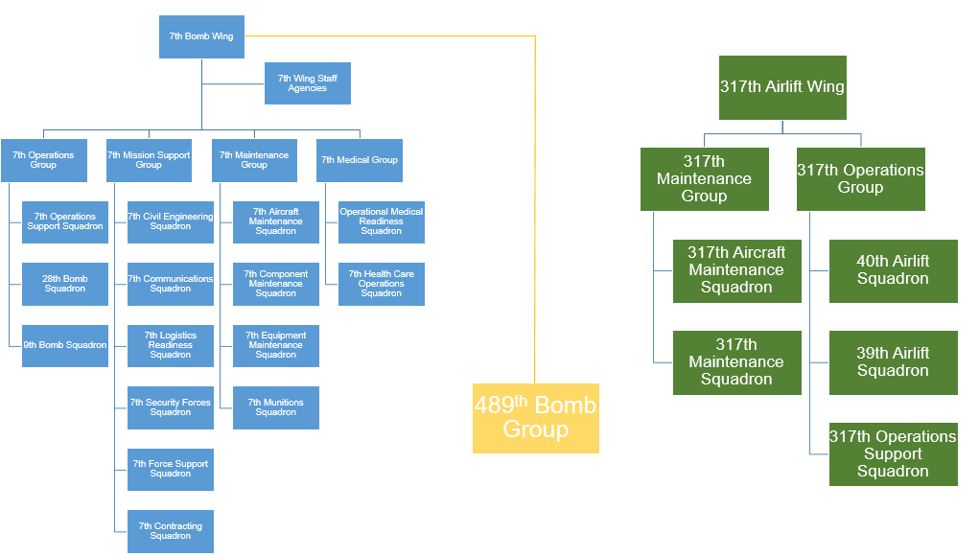

Wing Staff Agencies:
- Legal
- Public Affairs
- Inspector General
- Comptroller Squadron (CPTS aka Finance)
- Chaplain
- Safety
- Protocol
- Wing Plans
- Equal Opportunity
- Command Post
Tenant Units:
- 489 Bomb Group
- 436 Training Squadron
- ACC Training Support Squadron
- 29 Training Systems Squadron
- 337 Test and Evaluation Squadron
- 77 Weapons Squadron

Resources:
- Dyess Directory: https://www.dyess.af.mil/Contact-Us/Directory/
- Dyess Force Support Squadron: https://www.dyessfss.com/
- Dyess Military One Source Page: https://installations.militaryonesource.mil/military-installation/dyess-afb/military-and-family-support-center/service-specific-information
- Air Force Connect App: Download to your smartphone and search for Dyess!
- Dyess Sharepoint: https://usaf.dps.mil/teams/DyessAFB/7bw/SitePages/7-BW.aspx
- Dyess Finance: https://www.dyess.af.mil/Units/Support-Agencies/Finance/
- Dyess Social Media:


Chapter 9: Air Force Portal Utilization
The Air Force Portal is the DAF’s worldwide intranet. It allows users to quickly find authorities, relative data and information, applications and collaboration tools to help you do your job and live your life in the DAF. While the Air Force Portal has hundreds of resources and applications here are some key applications you should be knowledgeable on in order to operate as an officer and Airmen/Guardian:
Link to Air Force Portal: https://www.my.af.mil/
Note: All key applications discussed in the student handbook can be accessed utilizing the search AF Portal tool or by clicking the APPLICATIONS header on the AF Portal.

Airmen Development Plan (ADP) The Airmen Development Plan (ADP) facilitates the Force Development process for officers (2Lt through Lt Col) and civilians (NSPS Pay Band 2 & 3 and GS Equivalents). Force Development is a deliberate process to develop institutional and occupational competencies through education, training, and experience, to meet current and future AF mission requirements. ADP provides raters/commanders with access to their officers'/civilians' Career Briefs, Career Planning Diagrams, and eRecords for officers only (OPRs, training reports & decoration citations).
Air Force Personnel Accountability and Assessment System (AFPAAS): AFPAAS standardizes a method for the Air Force to account, assess, manage, and monitor the recovery and reconstitution process for personnel and their families affected and/or scattered by a wide-spread catastrophic event. The AFPAAS provides valuable information to all levels of the Air Force chain of command, allowing commanders to make strategic decisions which facilitate a return to stability. Note: Users should update AFPAAS information when in-processing and whenever there are changes in the member’s location (duty/home) and contact information.
Air Force Virtual Education Center (AFVEC): AFVEC provides information on Voluntary Education Benefits and offers a variety of self-service applications to Air Force members. Members sign on using their AF Portal account which then links them to their Air Force education record, CCAF progress report, personalized content, and local education center news.
Assignment Management System (AMS): AMS is an online program used for assignment preferences and career management for officer and enlisted Airmen. This is where officers can pull their Single Unit Retrieval Format (SURF).
SURF: A SURF is a one-page summary of your career, and it is used frequently by commanders to obtain a quick picture of an individual. You will need to ensure all information is up-to-date and accurately reflects your duty title, duty history, awards and decorations, and Air Force Specialty Codes. If your SURF is incorrect, contact your Commanders Support Staff (CSS), and they will help you fix it. For example, if you commissioned as a Distinguished Graduate from your university, you would need to go to your CSS and provide them with proof to make the update.
Defense Enrollment Eligibility Reporting System (DEERS): DEERS is a database that contains information for each Uniformed Service member (Active Duty, retired, or a member of a Reserve Component), US-sponsored foreign military, DoD and Uniformed Services civilians, other personnel as directed by the DoD (including the patient population serviced through the Military Health Services System), and their eligible family members. DEERS registration is required for the military health care system- TRICARE eligibility and enrollment. Incorrect information in the DEERS database can cause problems with TRICARE claims as well as other health care benefits, so it is critical to maintain your DEERS information.
Defense Travel System (DTS): DTS seamlessly automates the three DoD travel processes: authorization, reservation and voucher filing. Using DTS, travelers are able to generate travel authorizations, make trip reservations, and route travel requests for approval, all from their desktop workstation. In summary: if you are physically going TDY you will use DTS!
Joint Knowledge Online (JKO): JKO is the DoD’s unique and authoritative source for online joint training. JKO provides joint training resources including training courses, seminars, video library, and communities of interest.
LeaveWeb: LeaveWeb is a paperless Internet based leave tracking system that has automated procedures for requesting and tracking leave. This is your primary means to request leave (time off). Once you Extended Active Duty (EAD), you will accumulate 2.5 days of leave every month. Leave request approval is not automatic. Leave requests are dependent on unit’s manning and operations tempo. The best way to mitigate leave request disapprovals is by conversing intentions and leadership expectations ahead of time. Of note, LeaveWeb will only allow you to submit your leave request 30 days in advance for CONUS (state-side) travel and 60 days for OCONUS (overseas) travel. Do not make any financial obligations until your leave has been approved and has an authorization number. Once you have a leave authorization number, print the AF988 (these are your leave orders). As a brand-new officer, you will start with ZERO leave, so make sure you save for the holidays or other important dates.
Management Internal Control Toolset (MICT): MICT is an interactive application designed to assist in managing self-assessment programs. If you are tasked to run an additional duty program such as Unit Deployment Manager (UDM), Unit Fitness Program Manager (UFPM), etc. MICT will be utilized for assessment and inspections of all additional duty programs. It is highly recommended to review all training videos on MICT to become familiar with how to navigate the website.
milConnect: This application allows beneficiaries to review personal, health care, and personnel information from one reliable source, the Defense Enrollment Eligibility Reporting System (DEERS). milConnect can be utilized to update your DEERS information, find CAC reservation locations, view your TRICARE benefits, transfer education benefits, view your Service member’s Group Life Insurance (SGLI), etc.
My Aeromedical Services Information Management System/ Individual Medical Readiness Status (my IMR/ASIMS): The My IMR/ASIMS website provides users access to their Individual Medical Readiness (IMR) status, including IMR action list, Immunizations, and Deployment Health Assessments, and due dates.
My Force Support Squadron (myFSS): This a multiplatform application with the goal to centralize Airmen and Guardians career, benefits, service, and family information.
myEval: Tool utilized to submit OPRs and EPRs.
myDecs: Used to submit decorations and medals.
myFitness: Utilized for all things members’ Physical Fitness Assessments. Gives PFA notifications, records PFA results, allows members to schedule PFAs, and tracks members’ fitness goals and history.
myLearning: Provides various DAF computer base trainings (CBTs).
myPay: myPay allows you to manage your pay information, leave and earning statements, W-2s, adjust TSP, etc.
myPers: DAF knowledge and incident center. This is where the Air Force and Space Force will be able to look up messages that were sent out to the enterprise on policy or program changes and career field updates. Furthermore, this system is vital in finding Personnel Services Delivery Guides (PSDMs) which supplement AFIs with the process and procedure breakdowns.
myVector: myVector is an enterprise solution that supports the Air Force's goal to provide a standardized process available to all Airmen for career development and mentoring. Airmen can be proactive about their career development and mentoring relationships. It's also a mechanism for the Career Field Management (CFM) teams to communicate specific job information to their members by providing job descriptions, typical job duration estimates, and typical follow-on job recommendations from each of the job "buckets" defined on their members' pyramids. Through the combination of an Airman's specific duty history information and the CFM team-defined general recommendations, MyVector provides Airmen the ability to fully develop a career plan. The My Mentoring feature completes the system view of the whole picture.
Talent MarketPlace: Sub application built into myVector. This is where you will input your future job and location preferences. Additionally, if you were to compete for a special board (i.e. AFROTC Instructor billet), you would go WAPthrough Talent MarketPlace to submit your application. Talent MarketPlace is also a place for your career field to communicate with you, track your experience, and so much more.
Military One Source: This website provides an abundance of resources for military members and their dependents. Resources include financial and benefits information, mental health resources, information on Permanent Change of Station (PCS)ing, etc.
PCS Specific: Military One Source is critical to your PCS move and provides key resources for scheduling and navigating your PCS:
General Information on scheduling your PCS can be found at: http://www.move.mil/tutorials
There are three types of moves that you can do to accomplish your PCS. These include Household Goods Move (HHG) which is when movers scheduled by the Traffic Management Office (TMO) will come move your household goods. A second option is a Personally Procured Move (PPM) in which you will move your own household good and be reimbursed. The third option is a Partial Do It Yourself Move (DITY) in which movers will move a majority of your household goods but you will also move some of your goods.
You should view your entitlements and information on which move move best fits your PCS needs by visiting:
https://move.mil/entitlements
https://www.military.com/pcs/a-dity-move.html
Personnel Records Display Application (PRDA): PRDA is an electronic viewer for the Automated Records Management System (ARMS) containing role based access (RBA). PRDA allows commanders, supervisors, first sergeants and many more access in the performance of their official duties and within their jurisdiction to view both enlisted and/or officer Unit Personnel Record Groups.
TRICARE: TRICARE is the primary healthcare system for the DoD. TRICARE covers medical, dental, vision, and other medical needs for you and your dependents. Active Duty members are covered under the TRICARE Prime plan for members within 50 miles from their military installation. Members 50 miles from the nearest military installation will be covered under TRICARE Prime Remote. Members who are stationed overseas will be covered under TRICARE Prime Overseas.
For more information on TRICARE Plans please visit:
https://www.tricare.mil/Plans/HealthPlans
https://www.tricare.mil/ContactUs/CallUs/AllContacts
To Review your TRICARE Patient Portal where you can view your medical history and records please visit:
https://www.tricareonline.com/tol2/prelogin/mobileIndex.xhtml
Virtual Military Personnel Flight (vMPF): Allows members to view ribbon rack, career brief, duty history, education history, promotion eligibility, etc.

Chapter 10: Officer Pyramid/Pathway
While you are just beginning your career in the DAF, it now the time to begin mapping out your career. myPers provides officer career development briefs which can be found here: https://mypers.af.mil/app/answers/detail/a_id/46529/p/9/c/348. Officers should also have a strong familiarity on their CFETP. All CFETPs can be found on ePUBs. Within each officer’s CFETP is a career pyramid, which serves as a guide to an officer’s respective career progression based on their AFSC. Samples can be found below:
64P-Contracting
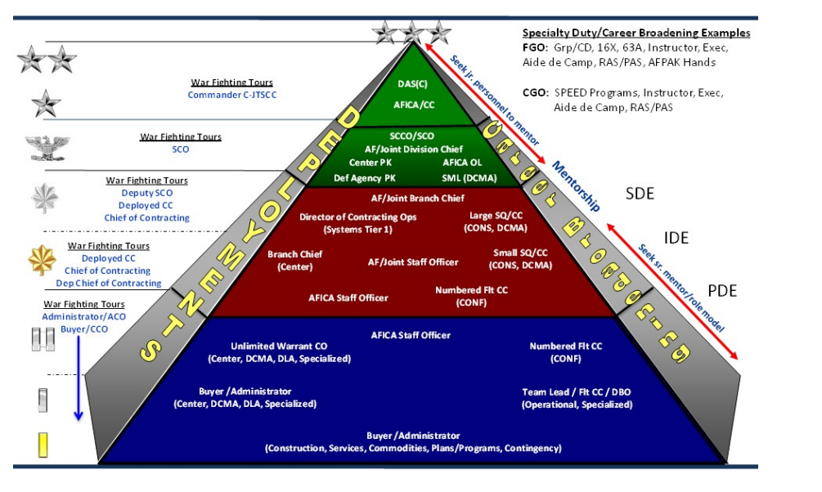
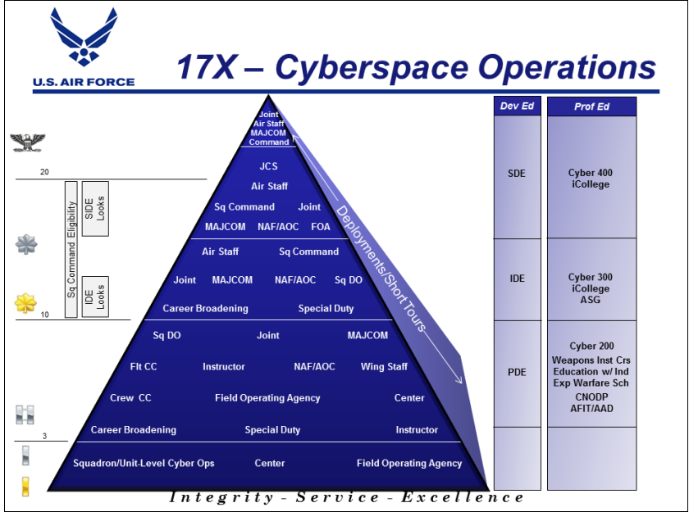
17X-

Ribbon/Rainbow Charts: Are a great tool for you to utilize to map out your career and track key milestones/ goal progression. Your respective career field milsuite page or OAT may have samples for you. Here are some samples of a ribbon/rainbow chart:

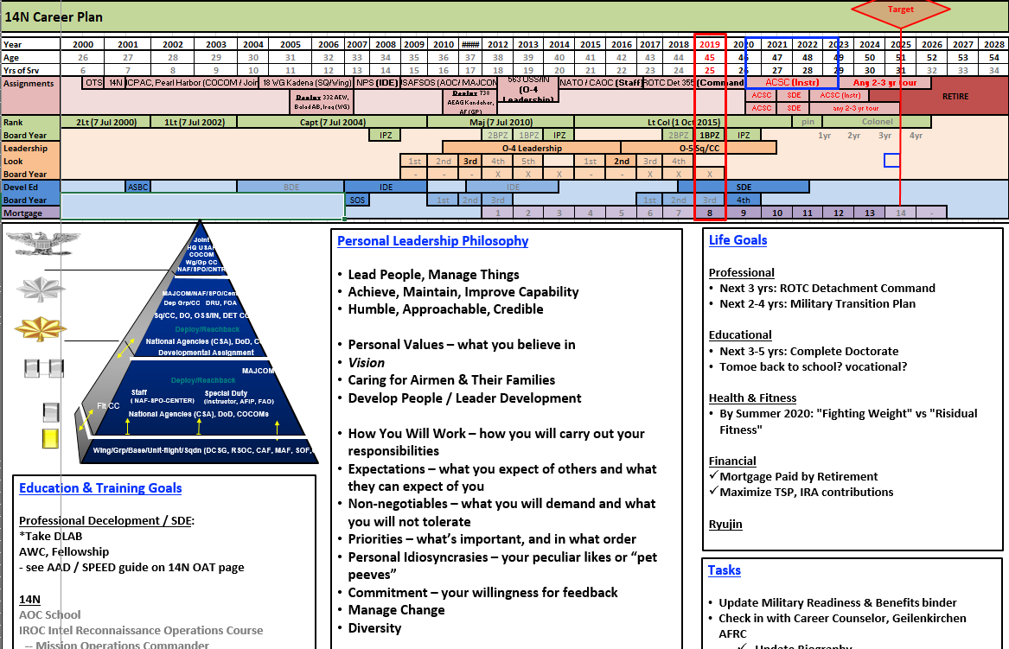
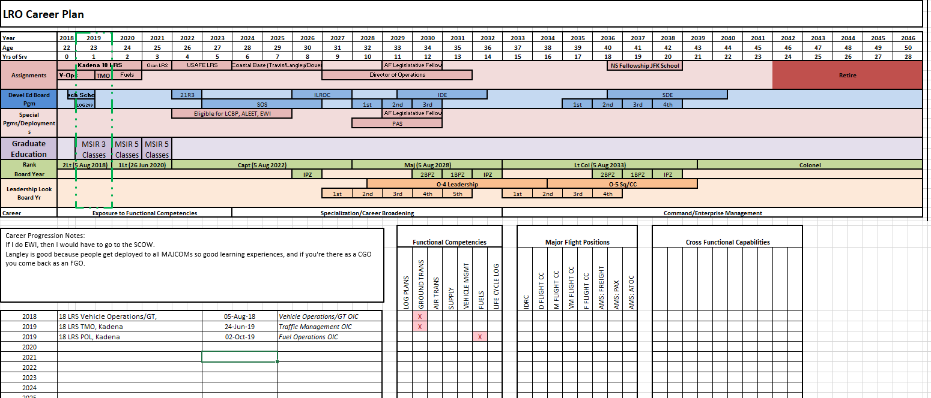

Tracking Training: It is important to understand how your training will be tasked and processed. The Air Force is currently in the works of tracking all career field training records in myTraining. Some career fields may require you to track all completed training tasks located in your CFETP. You should ask your supervisor immediately on how your training will be tracked.

Chapter 11: Promotions/ Talent Marketplace
Promotions
It is important to note that promotions are not simply just based on TIG and TOS. Promotion is also based on performance and demonstrated potential to serve in the next higher grade. You should review DAFI 36-2501, Officer Promotions and Selective Continuation.
Break down of TIS, TOG, and PME requirements
- First Lieutenant: 24-months TIG calculated from commissioning graduation date of rank (CGDOR)
- Captain:
  - 24-months TIG from date the officer promotes to first lieutenant in the promotion zone (IPZ) or when the Secretary of Defense (SecDef) approves the list-whichever comes first. If a first lieutenant is not promoted IPZ then they will be considered for above-the-promotion zone (APZ).
  - Professional Developmental Education (PDE): Captains may attend Squadron Officer School (SOS) before pinning on the rank of Major.
    - For more information on SOS visit: https://www.airuniversity.af.edu/SOS/
  - Each quarter first lieutenants are considered for promotion to captain in one of the following six competitive categories:
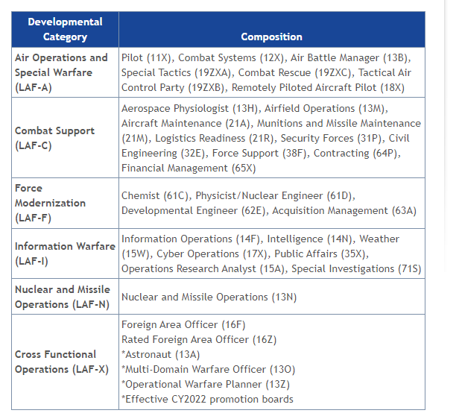

- Major-Major General
  - Will meet a promotion board.
  - Intermediate Developmental Education (IDE): Majors will complete Air Command and Staff College
  - Senior Developmental Education (SDE): Lieutenant Colonels will complete Air War College
For promotion to Major through Colonel the six developmental categories have been established in which eligible promotes will compete for a promotion line number in their respective developmental category.

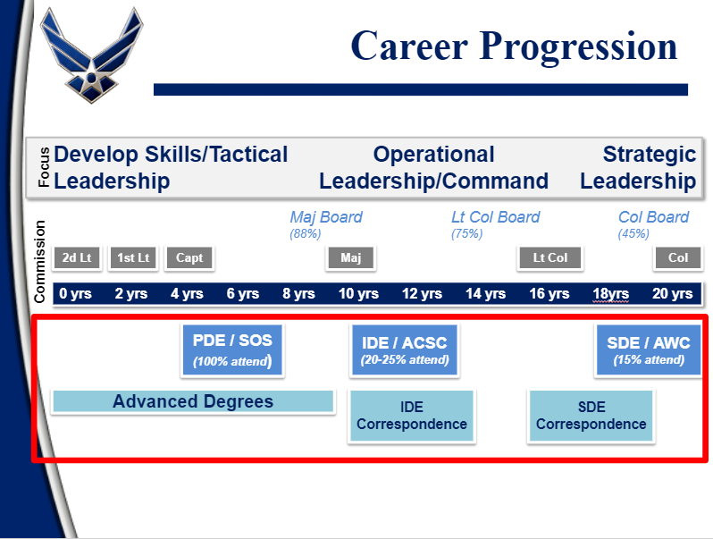

There are special circumstances which can impact assignments:
- Humanitarian
- Exceptional Family Member Program (EFMP)
  - EFMP is a Department of Defense program offered by all branches of the military. It is a mandatory enrollment program for all active duty Airmen and Guardians with a special needs family member.
  - It is important to note that not every base is authorized to support the EFMP.
- Join Spouse
  - This program allows you to PCS with your active duty military spouse.
  - It is extremely important to work with your officer assignments team and military personnel flight to ensure you and your spouse are coded correctly for a join spouse assignment
- High School Senior Assignment Deferment (HSSAD)
  - This allows military families with high school seniors about to graduate the ability to remain in-place until 60 days after graduation.
- Court-Ordered Child Custody Assignment/Deferment (CCCA/CCCD)
  - Allows for assignment changes and deferments for military members. The assignment teams will now take into consideration CCCA/CCCD.
- Career Intermission Program (CIP)
  - Allows active duty members a one to three year break from active duty to meet personal or professional needs outside of the service.
  - This program transfers the active duty member to the Individual Ready Reserve (IRR) in which the member will incur a “one month for one month” ratio.
  - CIP allows participants to retain full medical and dental benefits for themselves and eligible dependents, as well as exchange and commissary benefits. Participants also receive a monthly stipend of one-fifteenth of their basic pay.

Talent MarketPlace (TM) AKA your gateway to assignments!
TM is THE Air Force Officer Assignment System (AFOAS). TM provides increased visibility of potential jobs to officers, visibility of officers’ preferences to commanders, and aids an officer’s assignment team (OAT). Each career field has an OAT (please see below for how to find your OAT). Commanders, billet owners, AFPC, and the officer are the stakeholders of TM. Assignment matches are based off of DAF mission needs, MAJCOM/Joint priorities, officer professional development, personal preferences, and teamwork amongst the TM stakeholders. There are various steps an officer must complete in order to successfully navigate and utilize TM. It is critical that an officer updates their TM profiles regularly! If you have not created your TM profile yet you should take the time to do that now…
How to create your TM profile:
1) Log onto "MyVector"
2) Click on "Talent Marketplace" button at top of MyVector page
3) Click on "Update my Profile" tile and update your supervisor information. If you can't locate your supervisor in the search tool, it's likely your supervisor hasn't created a MyVector account yet. Please notify your supervisor of the requirement to log-in
Note: If able, log-in to MyVector using Chrome, Firefox, or Edge. Use compatibility view if utilizing Internet Explorer.
Vulnerable to Move List (VML): The VML is broken down in two categories-summer and winter. You will fall in either category based on your EAD date. The summer VML window dates ranges from August to June with report no later dates (RNL) ranging from June to September. The winter VML ranges from February to October with RNL dates ranging from October to May.
- Initial VML: The initial VML identifies all officers who are eligible to PCS.
- Final VML: The final VML will be posted on AMS by AFPC and officers matched using TM will have their new assignment posted on TM.
For more information on TM and the AFOAS to include training videos visit: https://mypers.af.mil/app/answers/detail/a_id/28230/kw/talent%20marketplace/p/9
Assignments myPers: https://mypers.af.mil/app/categories/c/20/p/9
AFPC TM Milbook: https://www.milsuite.mil/book/groups/afpc-assignments-talent-marketplace
Types of Deployments:
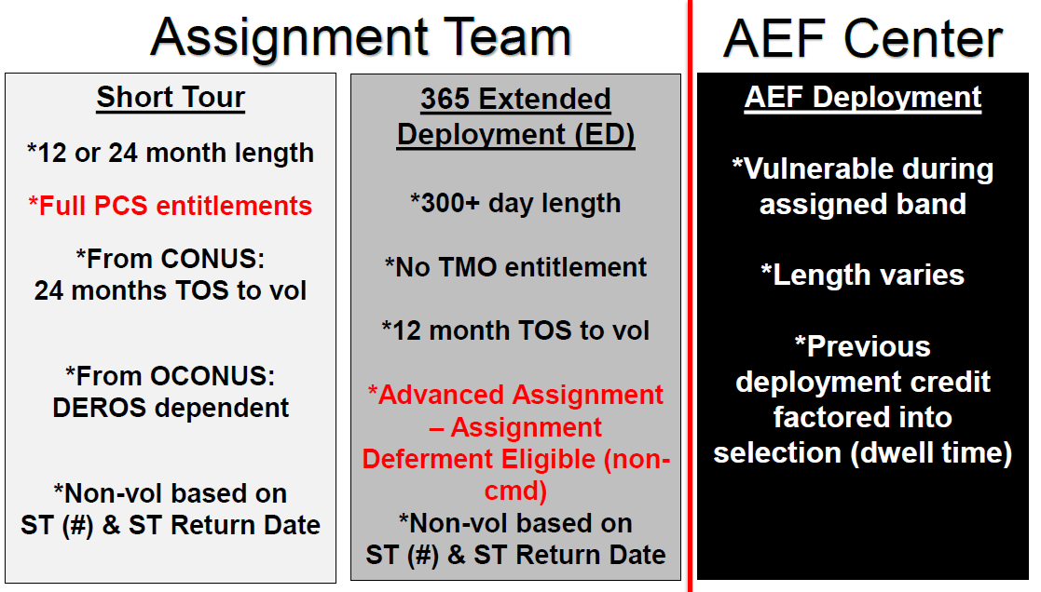
OAT: Each career field’s OAT contact information can be found on myPers under the assignments tab. Scroll down to AFSC Specific Officer Assignments and pick your officer category. From there you will be able to find your specific career field.
Each OAT will usually have a milsuite page which provides tons of great resources on career field specific information: https://www.milsuite.mil/book/groups
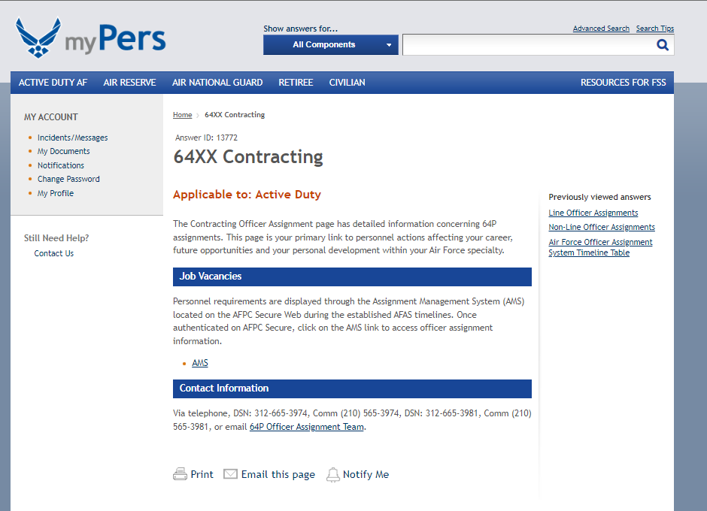
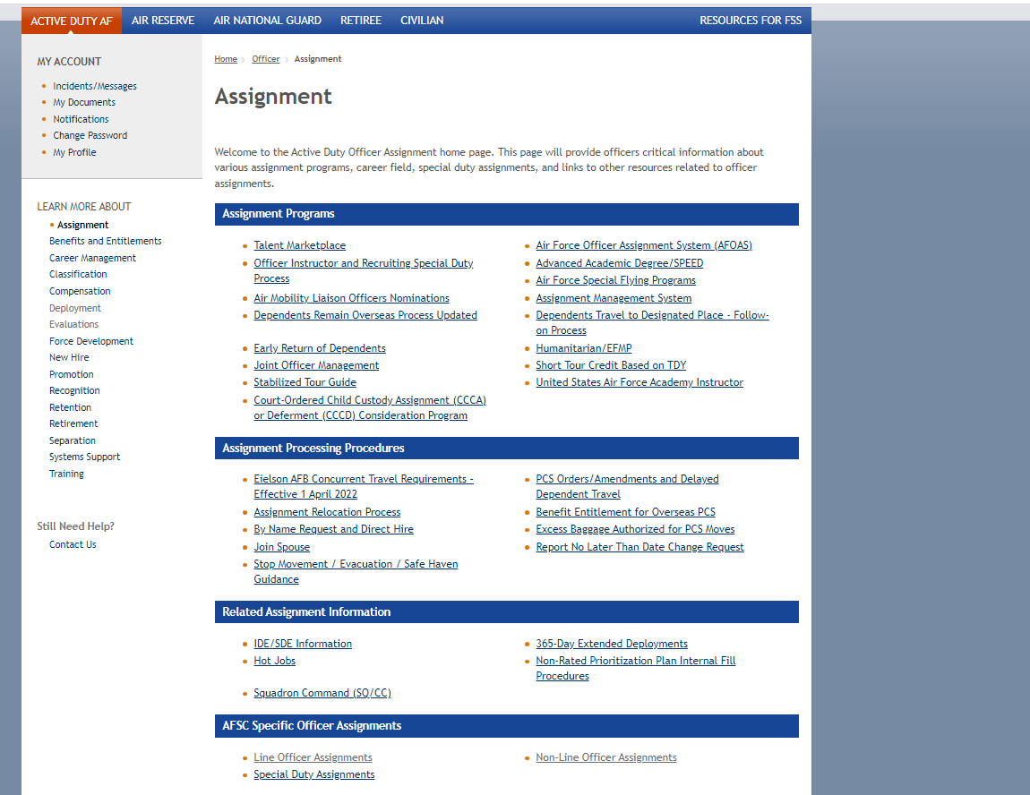

Chapter 12: Evaluations (EPR/OPR/ALQS)
When writing evaluations officers should reference AFI 36-2406, Officer and Enlisted Evaluation Systems.
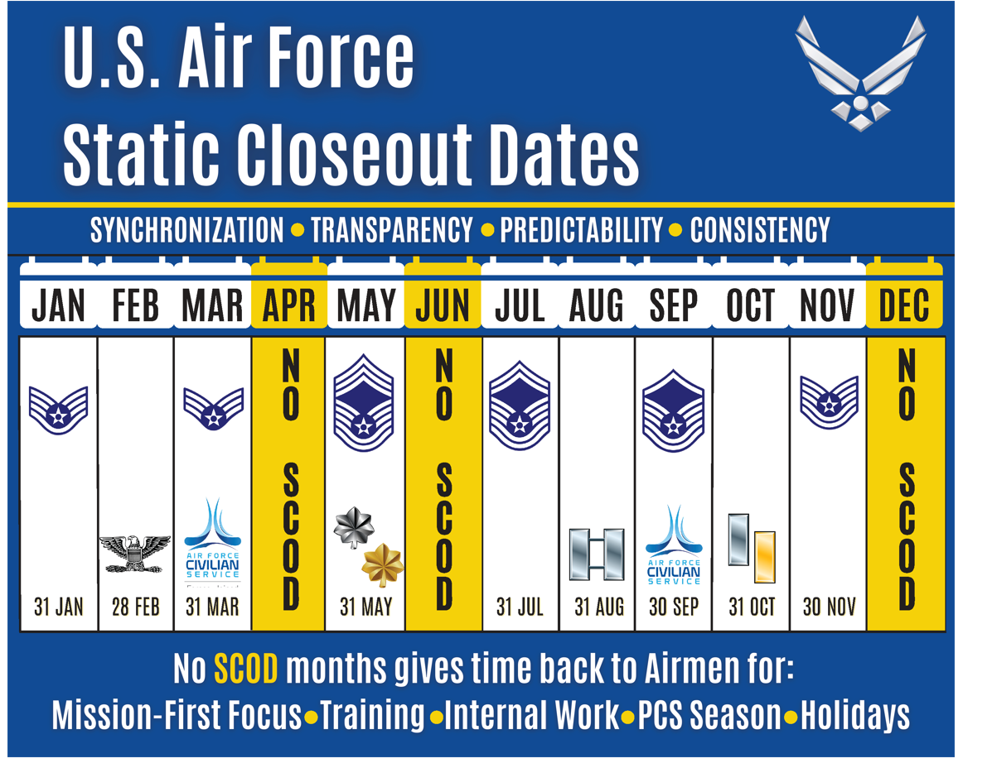
Static Closeout Dates (SCODs): Essentially tells Air Force officers and enlisted member when their EPRs and OPRs are due.

Officer Performance Reports (OPRs). Your OPR communicates to you, your boss, and your career field of your career progression and next job/assignment/school/special duty push. You will want to take your job and bullets very seriously. You will need to ensure all bullets are formatted in an Action-Impact-Result format. Additionally, the more statistical data you can capture, the stronger your report will be. For example, you can capture how many man-hours or dollars were saved as a result; or how many agencies or personnel you worked with to create “x” product. Lastly, reach out to your supervisor to see if your unit has a Unit Writer Guide. This guide will outline evaluation deadlines, approved acronyms, awards and decoration processes, performance recommendations, and so much more. AF707 is the form for OPRs and AFI 36-2406

1) Filling out your OPR. You will need to refer to AFI 36-2406 Table 3.1 and Attachment 3 for instructions on how to complete AF Form 707.

AF707 Section I & II example.

2) Record of Performance (ROP). You will need to compile your Training Report and Letter’s of Evaluation (LOEs), SURF, PFA Report, and OPR. This will need to be compiled into a single PDF file. This will be added to your Virtual Processing Center (vPC) site.
3) Training Report, Change of Rating Official, and Annual Report.
1. Training Report (TR). When you attend Tech school, you will receive a training report instead of a performance report. If you earn any accolades such as Distinguished Graduate or Honor Graduate, you can capture this on your OPR. Ensure your CSS updates your records in MilPDS.
2. Change of Rating Official (CRO). If your current supervisor has rated on you for 120 days and they are expected to depart, you will have a CRO report close-out instead of an annual OPR. Your annual OPR time will then restart. If your current supervisor did not have 120 days of supervision, you will maintain your original OPR close-out date.

For additional guidance on how to write an OPR visit: https://mypers.af.mil/app/categories/c/542/p/9

Stratifications. Stratifications are captured on your OPR and Letters of Evaluation (LOEs). Stratifications will now be limited to peer groups: grade, command position, and duty title. Second Lieutenants will not be stratified. For more information on strats visit: https://www.af.mil/News/Article-Display/Article/2519199/air-force-announces-officer-stratification-guidance/fbclid/IwAR079hU1dQOs7xk7dfzyjZLh3XuekJ7hl1SXtrh66wugDh5TMxYImH6kdJo/fbclid/IwAR20UK3NnuOxAq-yz-3J_YY2BB0wrAi7bCFIevJz6i0nxA-fKDlm27n70VY/fbclid/IwAR0CqmT5A3fXG2IxDJHgbeCxnsm6ozsXeSl25nBCSSQtef6UJAzgmWmumzA/
Enlisted Performance Report (EPR): “All enlisted personnel in the grade of SrA through CMSgt will receive an evaluation as of the appropriate static close-out date (SCOD) for their grade. AB, Amn, and A1Cs will receive an evaluation upon completing a minimum of 36 months in service (TIS) as of the SrA SCOD” (Reference AFI 36-2905, Para. 4.3.1.). Writing an EPR versus an OPR is completely different.
As a supervisor, you can encourage the ratee to provide you with inputs for their EPR on specific accomplishments, but you will not direct them to write or draft any portion of his or her performance report (Reference AFI 36-2905, Para.1.6.3.6).
For additional guidance on how to write an EPR visit: https://mypers.af.mil/app/categories/c/542/p/10

Sample EPR vs. OPR:

Feedback: Feedback is given at three levels (initial, midterm, evaluation report-OPRs/EPRs).
1. Initial: Per DAFI 36-2406, Officer and Enlisted Evaluation Systems Table 2.1 “The rater must conduct the initial feedback session within the first 60 calendar days he/she initially begins supervision. This will be the ratee’s only initial feedback until they have a change of reporting official”. During your initial feedback session, your supervisor will outline their standards and expectations.
2. Midterm: “The rater must conduct the midterm feedback session midway between the date supervision begins and the projected close-out date of the next OPR/EPR” (DAFI 36-2406). This feedback will cover your performance, strengths, weakness, and create an environment for candid dialogue with your supervisor.
3. Evaluation: Your third feedback is your OPR. Before you sign your OPR, your supervisor will sit down with you and discuss the outcome of your annual report. Once again, this provides an opportunity for two-way dialogue. If you are in a supervisory role, you will do the same three- step process for your Enlisted Troops.

Routing Feedback/OPRs/EPRs:
You will utilize myEval to route and sign all feedback, OPRs, and EPRs. Your unit’s Unit Program Coordinator (UPC) and Commander’s Support Staff (CSS) will also be involved with the flow chain of routing your feedback/OPR. For information (fact sheets and training videos) on myEval please view: https://myfss.us.af.mil/USAFCommunity/s/usaf-evaluation-management

Chapter 13: AF1206 Workshop
Awards, decorations, and evaluations all require mastering the art of writing. While writing a decoration does not require bullet format, knowing how to write is key to successfully highlight your troops and your own accomplishments.
AF1206: The AF1206 is the documents to submit awards on. You should access the most current version of the form through E-pubs.
Resources: There is an abundance of resources to aid you in mastering the craft. This list is not all inclusive-
- AFH 33-337: THE TONGUE AND QUILL, Chapter 19
- First Sergeant Writing Guide:

- Air Force Competitive Writing:

- How to gain space on an AF1206:

General tips:
- For Annual Wing Award packages use little to no career field specific acronyms. Acronyms should be known to the reader/grader.
- Ask your unit for a Unit Writer Guide/ common abbreviations list. Some MAJCOMs have a document specific to the MAJCOM.
- Award package boards only have approximately four minutes to review packages. Don’t waste time with the acronym section. The reader should be able to go through without having to continuously to review the acronym section.
- Always write from the customer’s point of view. Get someone outside of your career field to read your package. If it makes sense to them it will make sense to those grading your packages.
- You can use explanation points. It is recommended for awards and recognition
- You can use commas, …, &, etc.
- Don’t be humble!
- Numbers and % are quantifiers
- Use excel to track spent, money saved, time, and manpower hours saved
- Always annotate if you are in a deployed environment
- Do not use a word in the same bullet twice
- You do not manage people= Lead people, manage projects
- Utilize how to save space PDF (attached)
- Do not use x’s after numbers unless back to back numbers: ex: 2x CGOQ winner just do 2 CGOQ winner.
- The “wow” “how” “pow” of impact is what grabs the reader and is what is most important.
- You do not always have to include Sq/Group/Wing/ level of award in bullet
- Avoid big/long words
- While the acronym list such as AFGSC common abbreviation list is a tool do not depend on it. Remember your reader has ~4 minutes to get through packages. Do not waste any time!!!

Decorations: All decorations will be routed through myDecs. Supervisors and Commanders, at all levels, are authorized to submit decorations for members.
Note: AFMAN 36-2806, Awards and Memorialization Program governs the DAF awards and decorations program.
A further break down of DAF ribbons and decorations can be found at: https://www.afpc.af.mil/Recognition/Decorations-and-Ribbons/
Training on how to build a decoration can be found at:

Chapter 14: Finances
Understanding military finances and benefits is crucial for you and the Airmen and Guardians you lead. You should understand how to read a Leave and Earnings Statement, retirement benefits, Thrift-Savings Plan (TSP), and other entitlements.
As a reminder myPay is the system utilized for military finances.
Here are some tools for your toolbox:
What is an LES and how do I read it? For information on how to read your LES, view the document below. Your base finance office should help you decipher any items and any discrepancies.
The Defense Accounting System (DFAS) is your one stop show to understanding the different sections of your LES: https://www.dfas.mil/Portals/98/Documents/Military%20Members/Payentitlements/aboutpay/AirForce_reading_your_LES.pdf
How does my pay work? Your pay is separated into three different entitlements and allowances: Base Pay, Basic Housing Allowance (BAH), and Basic Assistance for Sustenance (BAS). Base Pay is taxable; BAH and BAS are not.
- How to calclulate my Base Pay? Review the following chart using your rank and time in service: https://www.dfas.mil/MilitaryMembers/payentitlements/Pay-Tables/Basic-Pay/CO/
- How do I know how much my BAH is? Input your bases zip code and your rank into the following calculator: https://www.defensetravel.dod.mil/site/bahCalc.cfm
- How do I know how much my BAS is? Find more information here: https://militarypay.defense.gov/pay/allowances/bas.aspx
- What is my Overseas Housing Allowance (OHA)? Learn more here: https://www.defensetravel.dod.mil/site/oha.cfm
- What is my Overseas Cost of Living Allowance (COLA)? Learn more here: https://www.defensetravel.dod.mil/site/cola.cfm
- One-Time Officer Clothing Allowance. You will need to file an AF1969 Form with your Finance Office to receive your one-time officer clothing allowance. Your finance office should process an AF1969 for you when you inprocess. To view more information of officer clothing allowance and to view the form read here: https://www.arpc.afrc.af.mil/Portals/4/DRIO/RIO-AF1969-Officer-Uniform-Clothing-Allowance.pdf?ver=2016-11-01-135653-173
- State Taxes. If you are stationed at a location where state taxes are waived for the military, you can change your residency by signing a form at your local Finance Office. For example, if you moved from California (a high state tax) to Texas (a no state tax), you could claim Texas as your residence. You can maintain your selected residency through all of your future military moves until you either separate or retire from the military. Of note, the authors of this guide are not tax professionals and you should seek professional tax assistance before making any decisions.
- Dislocation Allowance (DLA). DLA partially reimburses a Service member for expenses incurred when moving a household. A dislocation allowance is a flat amount and may be paid as a primary dislocation allowance, a secondary dislocation allowance, or a partial dislocation allowance, depending upon the circumstances of the household move. Only one dislocation allowance payment is permitted in a fiscal year, unless the situation qualifies as an exception in JTR, par. 050501.
For rates and more information members should view: https://www.defensetravel.dod.mil/site/faqdla.cfm

Retirement: While you have just started your career, now is the time to prepare for your retirement and to ensure your Thrift Savings Plan (TSP) is setup. If you commissioned after 1 January 2018 you will be automatically enrolled into the Blended Retirement System (BRS). Key points to the BRS include:
- The longer you serve the higher the benefit
- BRS keeps up with inflation
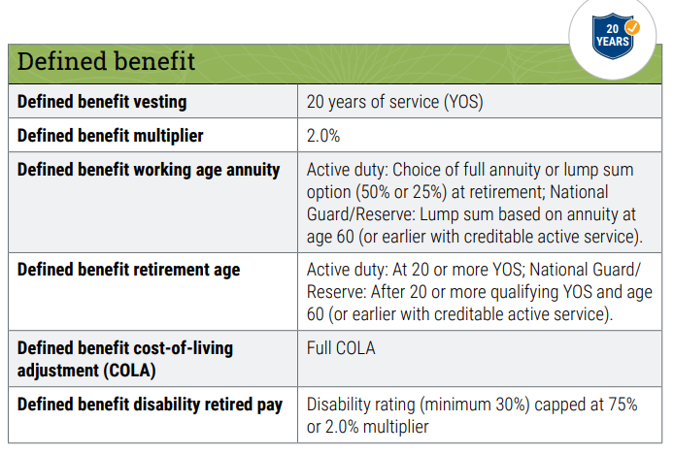
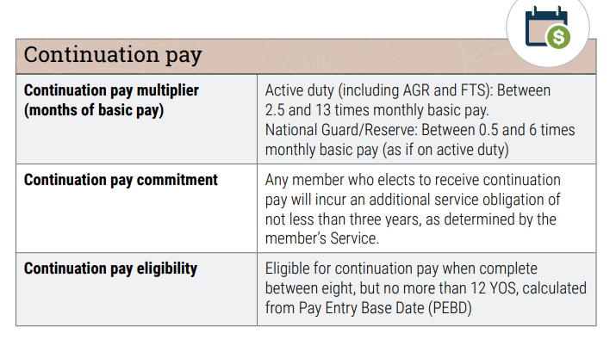
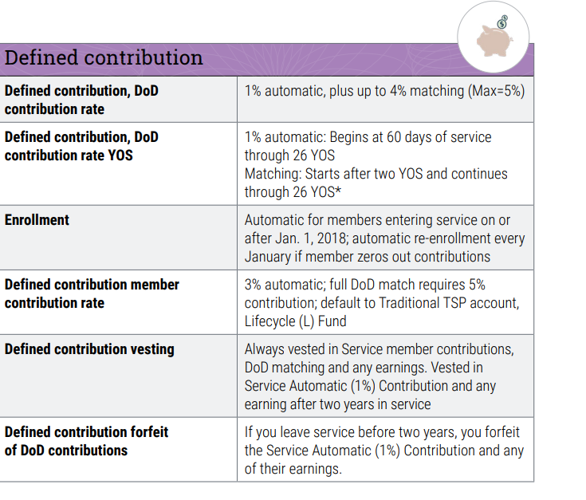
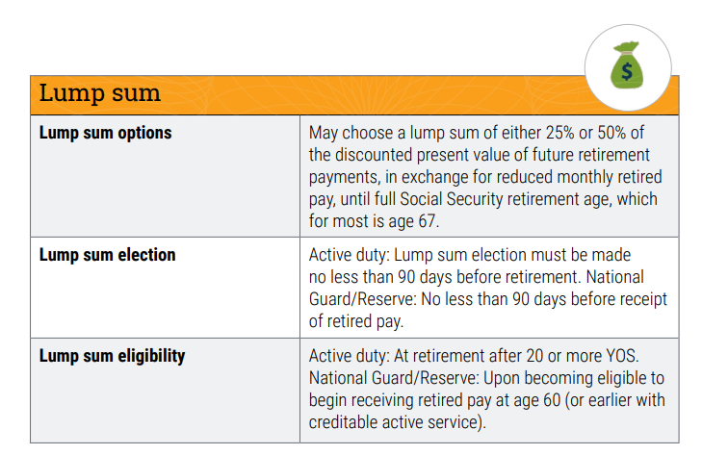
- You must serve at least two years or you forfeit the service automatic 1% contribution and any earnings

For more information on BRS visit: https://militarypay.defense.gov/
TSP: visit https://www.tsp.gov/

Misc. Financial Readiness Resources:
Financial Jumpstart-

Contribution Plan-

Mil Lifecycle-

Chapter 15: Commander’s Toolbox & Progressive Discipline
As an officer you have an important role in military justice. Officers are charged with the responsibility to uphold good order and discipline.
Administrative Tools: Administrative tools are utilized to administer and document discipline for members committing various rule infractions. Some administrative tools include:
- Unfavorable Information Files (UIFs): The UIF is an official record of unfavorable information concerning an Air Force member’s personal conduct and duty performance. It documents administrative, judicial, or nonjudicial censures concerning the member’s performance, responsibility, behavior, and so on. What documents go in a UIF depends on the rank of the offender (officer versus enlisted), what action was taken (court versus non-judicial punishment), and the punishment that was given (duration of punishment administered in an Article 15). UCMJ charges, Letters of reprimand, and counseling documents are all included in a UIF.
  - Refer to AFI 36-2907 Unfavorable Information File (UIF) Program
- Control Roster: Commanders may use the control roster to set up an observation period for individuals whose duty performance is substandard or who fail to meet or maintain Air Force standards of conduct, bearing, and integrity, on- or off-duty.
  - Refer to AFI 36-2907 Unfavorable Information File (UIF) Program
- Letters – Counseling (LOC), Admonishment (LOA), Reprimand (LOR): Oral counseling is given but documented but can be documented with a LOC, LOA, or LOR depending on the severity of the action.
  - LOC: Used to document verbal counseling. Examples of why an LOC include- tardiness, work no shows, Physical Fitness Assessment multiple failures, poor dress and appearance, etc.
  - LOA: Next level up from an LOC. LOAs are used to document more serious infatuations.
  - LOR: Next level up from an LOR. LORs are used to document serious inefficiency, impropriety, or misconduct.
Punitive Actions: Is categorized by nonjudicial and judicial.
- Nonjudicial: Is discipline not imposed by a court of justice. Commanders can issue an Article 15 within their units for minor offenses.
- Judicial: Judicial punishment is determined by a court-martial. Court-martials are broken into three categories: summary (SCM), special (SPCM), and general (GCM).
  - SCM: Tries minor offenses specifically for enlisted members only. An officer will oversee the SCM.
  - SPCM: Tries offenses of intermediate severity. A military judge will preside over a SPCM.
  - GCM: Tries the most serious offenses and is convened by a Numbered Air Force Commander or equivalent.
Resources:
- Manual for Court-Martials and UCMJ:
https://jsc.defense.gov/Portals/99/Documents/2019%20MCM%20(Final)%20(20190108).pdf?ver=2019-01-11-115724-610
- The Military Commander and the Law:
https://www.afjag.af.mil/Portals/77/documents/
Publications/MCL2019%20web7.pdf?ver=2019-03-26-151939-853
- AF Judge Advocate General’s Corps:
https://www.afjag.af.mil/
- AFI51-110: Professional Responsibility Program
- AFI51-304: Legal Assistance, Notary, Preventative Law, and Tax Programs

Chapter 16: Emotional Intelligence
“I believe all leaders need to have a solid understanding of what emotional intelligence is and how to use it in everyday life. In fact, emotional intelligence is helpful to simply being a better human. Had I understood the impacts that my own emotions, actions and behaviors had on others and better understood other people’s emotions, I might’ve saved myself a lot of heartache over the years. And it would have definitely improved the interpersonal relationships that matter in life, at work and at home.”
- JoAnne S. Bass, Chief Master Sergeant of the Air Force
Leadership has been described as an art. In order to master it we must be able to understand not only ourselves, but others as well. The DAF has continuously implemented emotional intelligence trainings through Professional Military Education, various leadership courses, and unit workshops. While there is no formal DAF-dictated platform for delivering emotional intelligence training it is critical for officers to be able to really grasp and exhibit emotional intelligence throughout their careers in order to effectively lead themselves and those around them. In fact emotional intelligence is now being evaluated through the Airman leadership Qualities.
Resources:
- Four Lenses:
https://fourlenses.com/
- Air University:
https://www.airuniversity.af.edu/LinkClick.aspx?fileticket=gU9NH00_4rM%3d
- PACE:
https://www.airman.af.mil/Products-and-Services/PACE-LI-Presentations/Emotional-Intelligence/
- American Management Association:
https://www.amanet.org/leading-with-emotional-intelligence/?fbclid=IwAR2Cl3iYNRyHQO6aSxMnoSjyvW5pGGYt8zPImvaBqWM3HAHTF8-HXLAWi9U

Chapter 17: Leadership 101
Your SNCOs should be your one of your primary mentors and “right-hand man”. Here are some tips from SNCOs for your toolbox:
- Time Management: When you are early in your careers, it is easy to burn yourself out by staying late and working weekends. Remember, your team has families, kids, and hobbies and that’s ok.
- Counseling: Not enough officers understand the LOC, LOR protocol. Educate yourself on the discipline process early so you understand the tools at your disposal and when the right time for each one is.
- Be patient. Learn to absorb knowledge from your SNCOs. Be consistent!
- Question the “we’ve always done it this way” mentality or “base ‘x’-isms.”
- CGOs are placed as Flight Commanders without knowledge of how enlisted development works. Examples:
  - EPRs
  - Professional Development Timelines (ALS, NCOA, SNCOA)
  - How Enlisted Force Distribution Panel Works
  - How Strats work
  - Support for Base Organizations
  - How to provide effective Feedback
  - Understanding the Enlisted Force Structure
- Never underestimate the perceptions your rank, title, and position carry and how it affects your team. Your unit will be a reflection of the values you uphold.
- Do not be afraid to be enthusiastic. Challenge yourself to find the “why” and share your perspective and motivation with others. If leadership can’t find the reason to do something, how can you expect your troops to find it?
- No one goes the extra mile for someone that is only in it for themselves. Take care of your people, even when it is the hard thing to do.
- Observe before changing anything (1-2 months) in order to understand the current process first.
- Understand that you do not know everything! Listen to the people who have more experience than you do. Understand that you are not always right! Learn to be ok with the fact you made a mistake and take constructive feedback when it is provided.
- Ask questions.
- Write down and learn the different acronyms. One acronym can mean different things to different organizations.

Chapter 18: Senior Leadership Perspective
No supplemental material for this chapter. Panel members will provide insight through class panel.
Chapter 19: Inspector General
The Inspector General (IG) is a leadership tool that all officers should be knowledgeable on. The IG promotes unit members and commanders to try to resolve issues at the lowest level first. The IG’s responsibilities include but are not limited to:
- Allegations of Injustice
- Violations of Law or Directives
- Gross mismanagement
- Fraud Waste and Abuse
- Abuse of authority
- Restriction or reprisal of members ability to access the IG
- Outside the chain of command support
- Fraud, waste, and abuse
- Mission effectiveness and efficiency
The IG’s responsibilities do not include:
- Conditions of employment for civilians
- Commander directed investigations (CDI)
- EPR/OPR appeals
- TRICARE complaints
- Criminal activity
Resources:
- AFI90-201: THE AIR FORCE INSPECTION SYSTEM
- AFI90-301: INSPECTOR GENERAL (IG) COMPLAINT SYSTEM

Chapter 20: Sexual Assault Prevention Program
There are two types of sexual assault reports that can be made:
- Restricted – confidential disclosure to SARC, VA, medical personnel, or chaplain
- Unrestricted – disclosure to chain of command, law enforcement, AFOSI, or the SARC; initiate AFOSI investigation

Sexual Assault vs. Sexual Harassment:
- Sexual Harassment: “Unwelcome advances, gestures, comments, or repeated requests that are sexual in nature.” Harassment can have an impact on an individual’s career and/or cause a work environment to be uncomfortable or hostile.
- Sexual Assault: “Intentional and unwanted sexual touching (or attempts to touch) another person when that person does not give or is not capable of giving consent
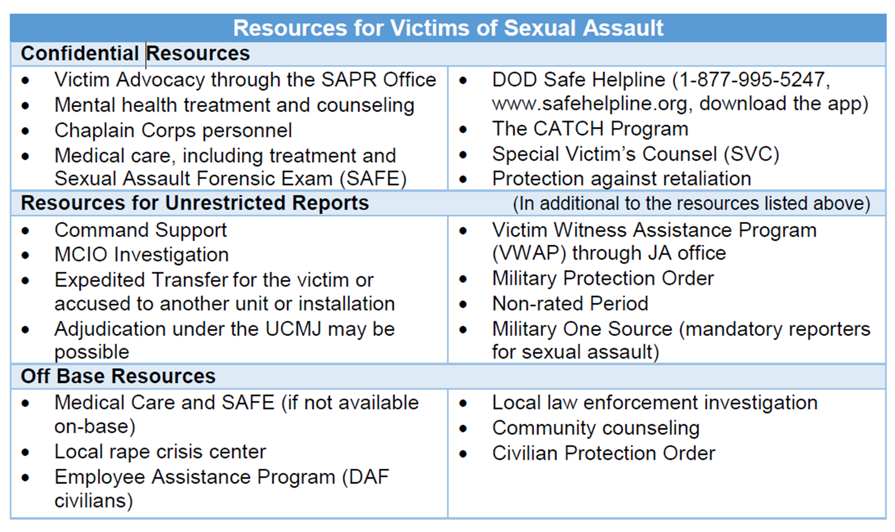
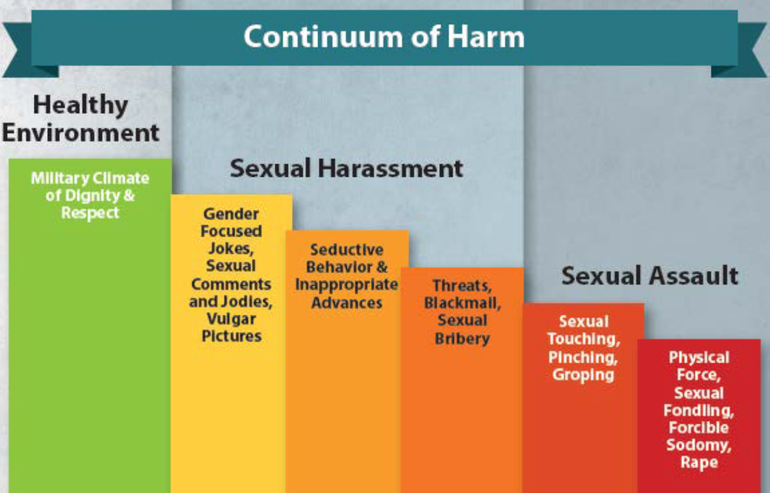

SAPR Office Location & Contact Information
217 5th St Bldg 7402 Room 170/171
Office: 696-5499/5449 VA Hotline: 696-7272 (SARC)

Chapter 21: First Sergeant
Diamond Wearing First Sergeants: The First Sergeant, known as the “Shirt”, is responsible for advising commanders on the readiness, health, morale, welfare, and quality of life of Airmen and families to ensure a mission-ready force. The Shirt is a SNCO who will wear a diamond on their chevron(s). The Shirt is a detached from the chain of command and is a critical resource to all Airmen and Guardians. Shirts are on call 24/7 and provide countless resources and methods of support. As an officer, you should be knowledgeable on what a First Sergeant’s role is and what resources they can provide. It is not your job to know how to solve every issue as officer but to know how to assist your Airmen and Guardians in need. This is where your First Sergeant can come in to assist you. Some of the key roles and responsibilities of the First Sergeant are:
- Advisor to the commanders
- Instill professionalism throughout the unit. First Sergeants exemplify the core values.
- Remain a credible source of information to unit members
- Respond to issues on a 24/7 basis
- Work with SELs to oversee unit readiness, training, health, morale, and quality of life
- Aid in the key spouse program
- Provide conflict resolution. First Sergeants remain neutral:

Additional Duty First Sergeants: Units may have additional duty First Sergeants assigned when a diamond wearing First Sergeant is not assigned or to supplement the duties of a diamond wearing First Sergeant. An additional duty First Sergeant is known as the “under shirt”. Under shirts do not attend the Air Force First Sergeant Academy (FSA) but will be put through some form of formal training in order to perform the duties of an under shirt.

Resources:
- AFI36-2113 THE FIRST SERGEANT
- AFI51-1201 NEGOTIATION AND DISPUTE RESOLUTION PROGRAM
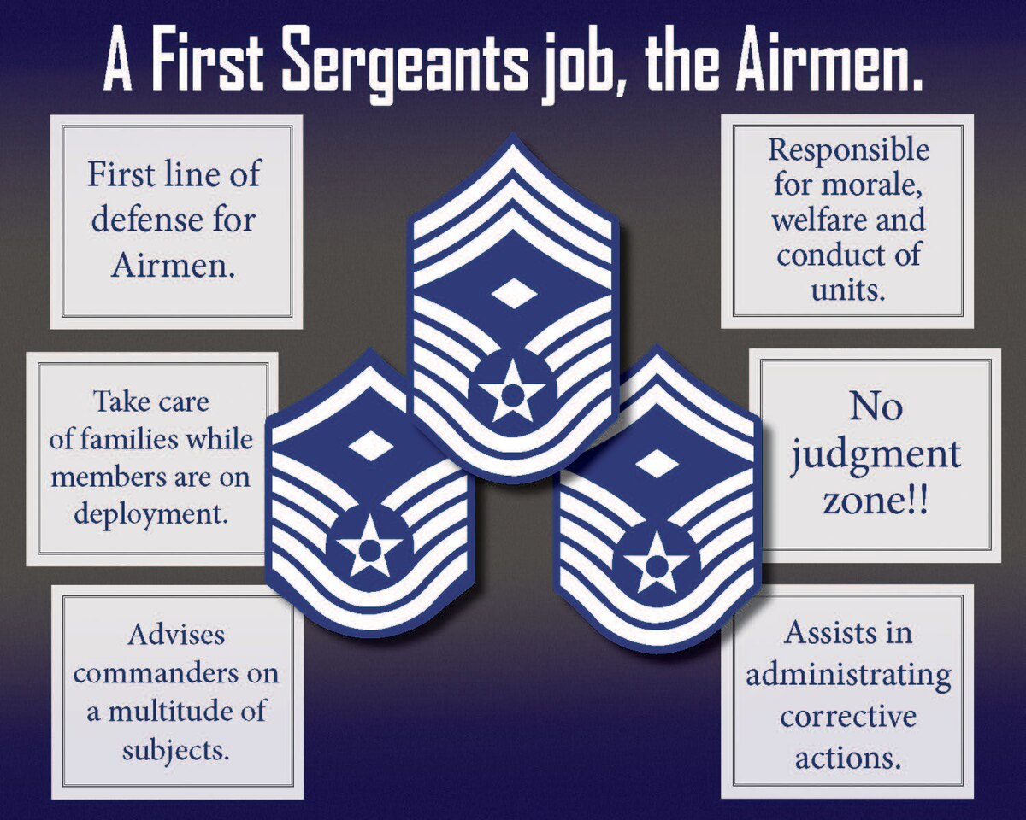

Chapter 22: Enlisted Force Structure
The Air Force has recently published an updated version of the infamous Little Brown Book formally known as AFH 36-2618, The Enlisted Force Structure. This document serves the purpose of outlining the roles and responsibilities on the three enlisted tiers, defines the concept of multi-capable Airmen, establishes foundational competencies and ten Airman Leadership Qualities (ALQ), summarized the Officer and Civilian Corps, and overall enforces a culture revolved around the concept of Airmanship. In the words of Nineteenth Chief Master Sergeant of the Air Force JoAnne S. Bass “All Airmen need to have a copy of these foundational documents-read them, understand them, and incorporate them into your daily lives”.
A copy of the Little Brown Book can be found at: https://www.airforcemag.com/app/uploads/2022/05/Brown-Book.pdf
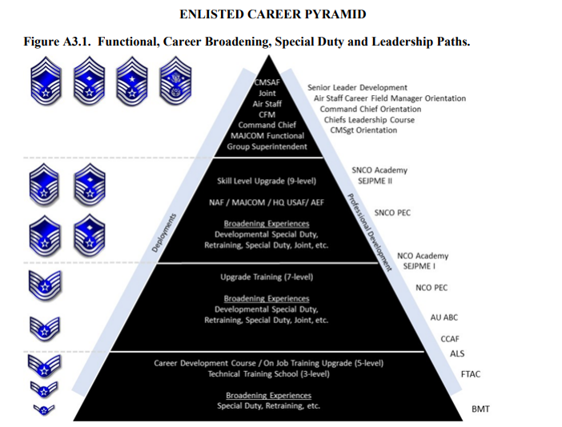

Enlisted Professional Military Education (PME)
Note: AFI 36-2502, Enlisted Airman Promotion and Demotion Programs governs enlisted members PME and promotion requirements.
Airman Leadership School: The Airman Leadership School (ALS) is the first level of Professional Military Education (PME) our enlisted Airmen experience. It is designed to be an entry level leadership enhancement course to prepare Senior Airmen for positions of greater responsibility by strengthening their ability to lead, follow, and manage while also gaining a broader understanding of the military profession and their role within the Air and Space Forces. Completion is required to receive Staff Sergeant pay. There are 68 Active Duty ALS Schools and 1 Air National Guard (ANG) School globally that is managed by their respective Major Command (MAJCOM). The Barnes Center provides program management guidance and comprehensive curriculum materials to each of these schools.
For more information on ALS visit: https://www.airuniversity.af.edu/Barnes/Airman-Leadership-School/
Noncommissioned Officer Academy: The Noncommissioned Officer Academy (NCOA) is the second level of Enlisted Professional Military Education (EPME) and prepares Technical Sergeants to be professional, war-fighting Airmen and Space Professionals who can manage and lead units in the employment of Air and Space power. Currently, there are 11 NCOAs worldwide.
For more information on NCOA visit: https://www.airuniversity.af.edu/Barnes/NCO-Academy/
Senior Noncommissioned Officer Academy: The Air Force Senior Noncommissioned Officer Academy (AFSNCOA) is the third level of enlisted PME. AFSNCOA prepares SNCOs to lead the enlisted force in the employment of air and space power in support of US national security objectives. There is a single in-resident AFSNCOA located at Maxwell AFB–Gunter Annex, Alabama.
For more information on AFSNCOA visit: https://www.airuniversity.af.edu/Barnes/AFSNCOA/

Enlisted Education
The DAF demands well-rounded and educated enlisted Airmen and Guardians. As an officer you should encourage your enlisted Airmen and Guardians to pursue their education and advise them to visit their unit’s local Education Services Office to create an education plan. It is important to note that as enlisted members move up in the rank structure, academic degrees may be required for promotion.
Community College of the Air Force (CCAF): The CCAF, offered by the United States Air Force, is a federal program granting two year accredited Associates Degrees. The CCAF has accreditation through the Southern Association of Colleges and Schools through the Air University. The programs offered combine the general education of regionally accredited civilian institutions with the technical education offered by the Air Force schools. Enrollment is automatic upon completion of Basic Military Training. College credits for a member’s CCAF degree are earned through Technical Training and Basic Military training and can transfer to additional undergraduate programs as well. Enlisted members can view their progress on their CCAF degree through AFVEC.
For more information on the CCAF visit: https://www.airuniversity.af.edu/Barnes/CCAF/
Note: The Defense Activity for Non-Traditional Education (DANTES) provides free College Level Examination Program (CLEP) testing which can help accelerate members in earning their CCAF or other degrees. The unit’s local Education Services Office can provide further information.

Enlisted Promotions
Weighted Airman Promotion System (WAPS): Is a weighted evaluation which determinates promotions to the ranks of SSgt through TSgt. Upon completion of WAPS testing enlisted members will be assigned a line number which will determine their promotion cycle.
Below the Zone (BTZ) Program: The BTZ program is designed to give exceptionally perfuming A1Cs the opportunity to promote to SrA six-months before to promotion eligibility.
For more information on BTZ visit: https://mypers.af.mil/app/answers/detail/a_id/26122/p/10/c/656
Promotion Cycles: Enlisted promotions are based on various factors such as time in grade (TIG), time in service (TIS), testing requirements, evaluations, PME, and various other factors such as WAPS testing.
For more information on enlisted promotions visit: https://mypers.af.mil/app/categories/p/10/c/656/p/10/c/656

Acknowledgements:
Content has been referenced from various DAF resources.
Air and Space Force Second Lieutenant Guide-
Captain Nethania Swanson, Det 585
Captain Michael Meaux, Det 145
Captain Mandela Littleton, Det 165

